Overview
This file is a specification of the model created by UML definition

Package List
Full Name | Summary
[Root]

[Root] Package

UseCase List
Name | Summary
Cancel class
Manage
schedule
Manage students
Manage students

View own timetable

Classifier List
Name | Type | Summary
Student | Actor
Teacher | Actor
Timetable Manager | Actor

Diagram

UseCase Diagram0[UseCase Diagram]

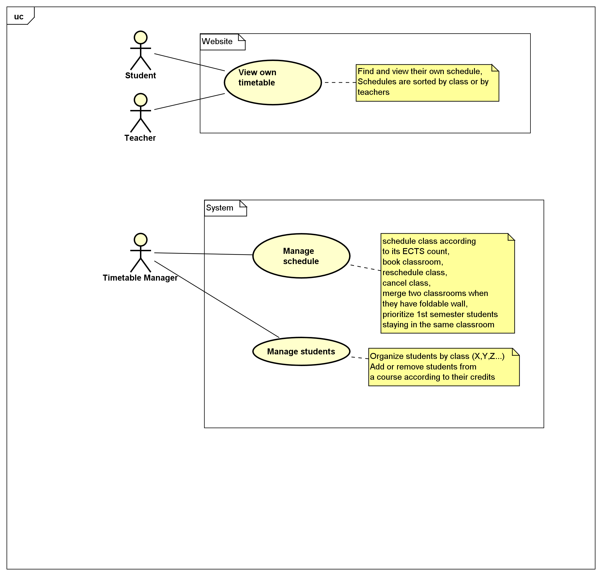

figure 1: UseCase Diagram0[UseCase Diagram]

UseCase

Cancel class [UseCase]

Namespace
[Root]

UseCase Description
Template | Astah Original
UseCase | Cancel class
Summary
Actor | Timetable Manager
Precondition
Postcondition
Base Sequence
Branch Sequence
Exception Sequence
Sub UseCase
Note

Manageschedule [UseCase]

Namespace
[Root]

UseCase Description
Template | Astah Original
UseCase | Manage  schedule
Summary
Actor | Timetable Manager
Precondition
Postcondition
Base Sequence
Branch Sequence
Exception Sequence
Sub UseCase
Note

Manage students [UseCase]

Namespace
[Root]

UseCase Description
Template | Astah Original
UseCase | Manage students
Summary
Actor | Timetable Manager
Precondition
Postcondition
Base Sequence
Branch Sequence
Exception Sequence
Sub UseCase
Note

Manage students [UseCase]

Namespace
[Root]

UseCase Description
Template | Astah Original
UseCase | Manage students
Summary
Actor
Precondition
Postcondition
Base Sequence
Branch Sequence
Exception Sequence
Sub UseCase
Note

View own timetable [UseCase]

Namespace
[Root]

UseCase Description
Template | Astah Original
UseCase | View own timetable
Summary
Actor | Student,  Teacher
Precondition
Postcondition
Base Sequence
Branch Sequence
Exception Sequence
Sub UseCase
Note

Class

Student [Actor]

Declaration
public class Student

Namespace
[Root]

Stereotype
<<actor>>

Relation (From Source To Target)
Name | Type | Target | Summary
 | Association | View own timetable

Teacher [Actor]

Declaration
public class Teacher

Namespace
[Root]

Stereotype
<<actor>>

Relation (From Source To Target)
Name | Type | Target | Summary
 | Association | View own timetable

Timetable Manager [Actor]

Declaration
public class Timetable Manager

Namespace
[Root]

Stereotype
<<actor>>

Relation (From Source To Target)
Name | Type | Target | Summary
 | Association | Manage  schedule
 | Association | Cancel class
 | Association | Manage students

